**User Cases**

~~-*when user submit request (amin)~~

~~-*when user upload image (amin)~~

-*when user open submission history (details, location,restore,delete) (amin)

-when user forgot password (amin)

~~-*when user pick location (amin)~~

-when user opens account page (amin)

-*when user submits request (amin)

*Use Case 4: Uploading a help Request*

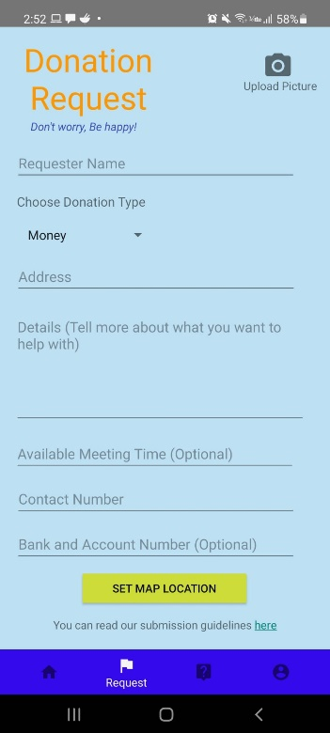

The moment users log into the app, they will be directed to the main page and they can proceed to make their help request by clicking the request button on the bottom of their screen.

On the request page, users will be greeted with the title Donation Request with the slogan Don’t Worry, Be Happy! Along with a few blank fields that they need to fill in in order to upload their request on the map.

Users have to fill in every field with a valid information for their request to be accepted. Any invalid input will be met with error message. Required information that users need to provide is their name, type of donation, address, donation details to describe their request, available meeting time, contact number and bank account information(optional) in case they want the donation to be transferred into their bank account. Users can also click the camera icon to upload pictures along with their request.

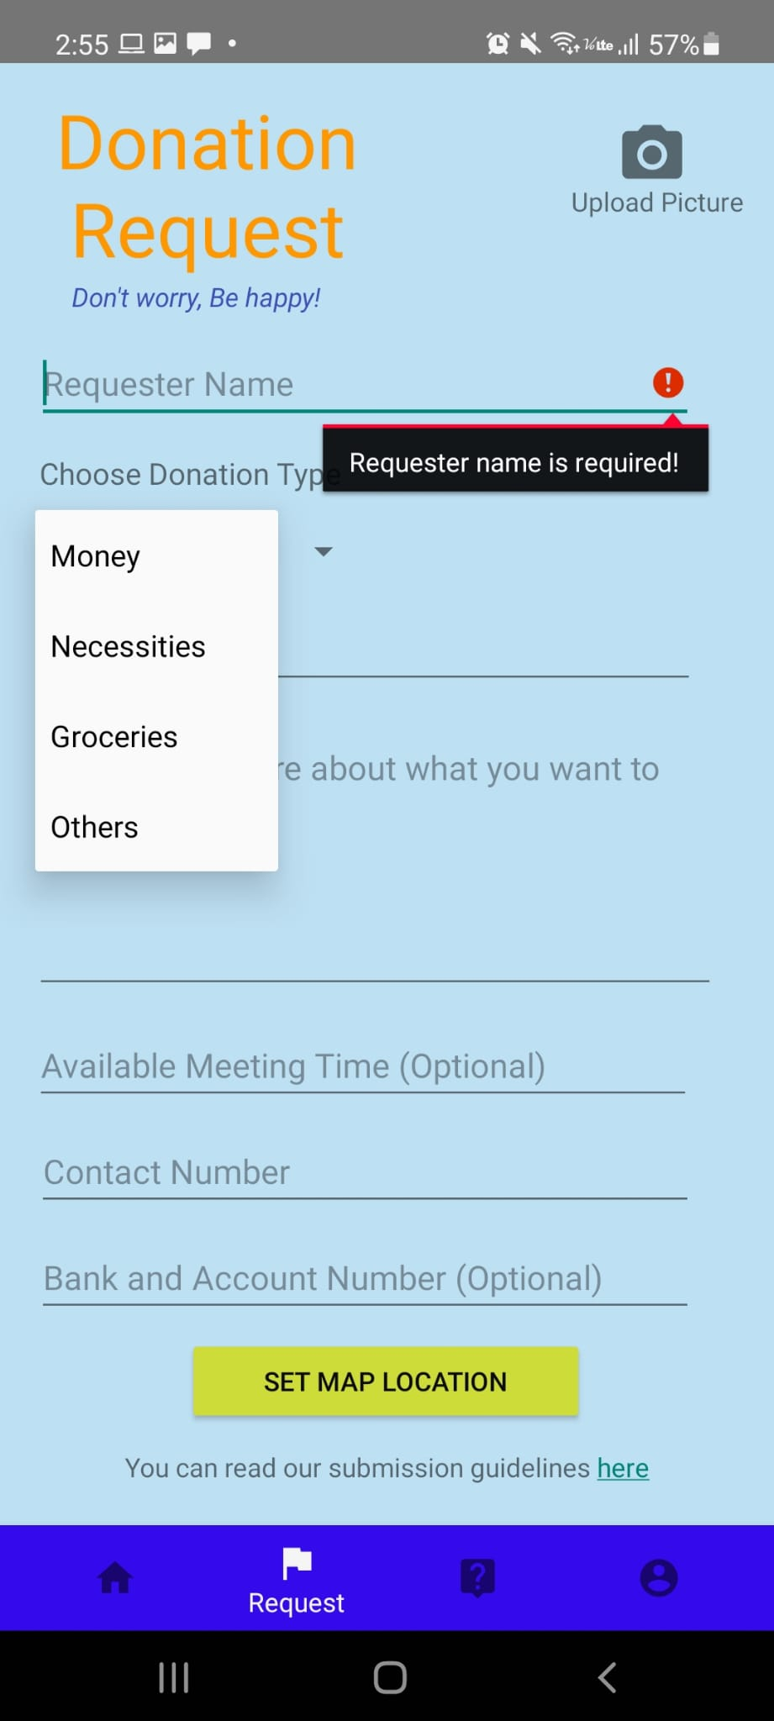

Error message will pop up if the requester name if left empty



Users can choose the type of donation they require from the drop-down menu in the *Donation type* field and choose *others* if they require other help than the option provided.

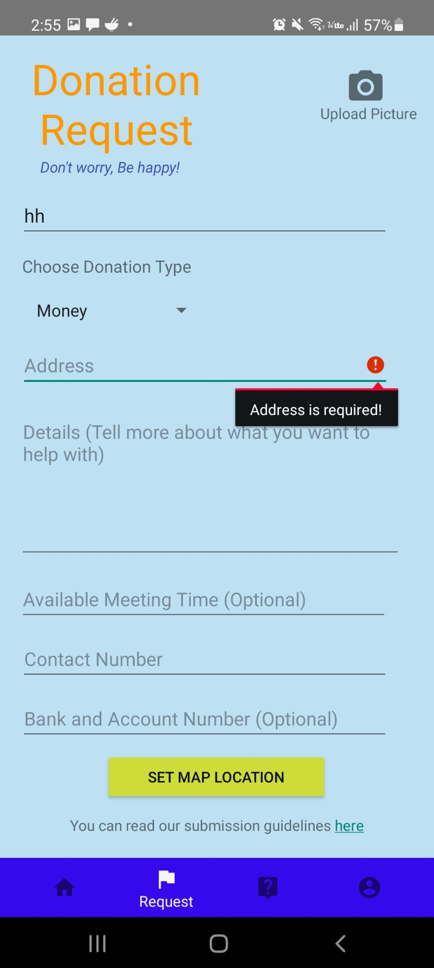

Example of error message that will pop up if the *address* field is left empty.

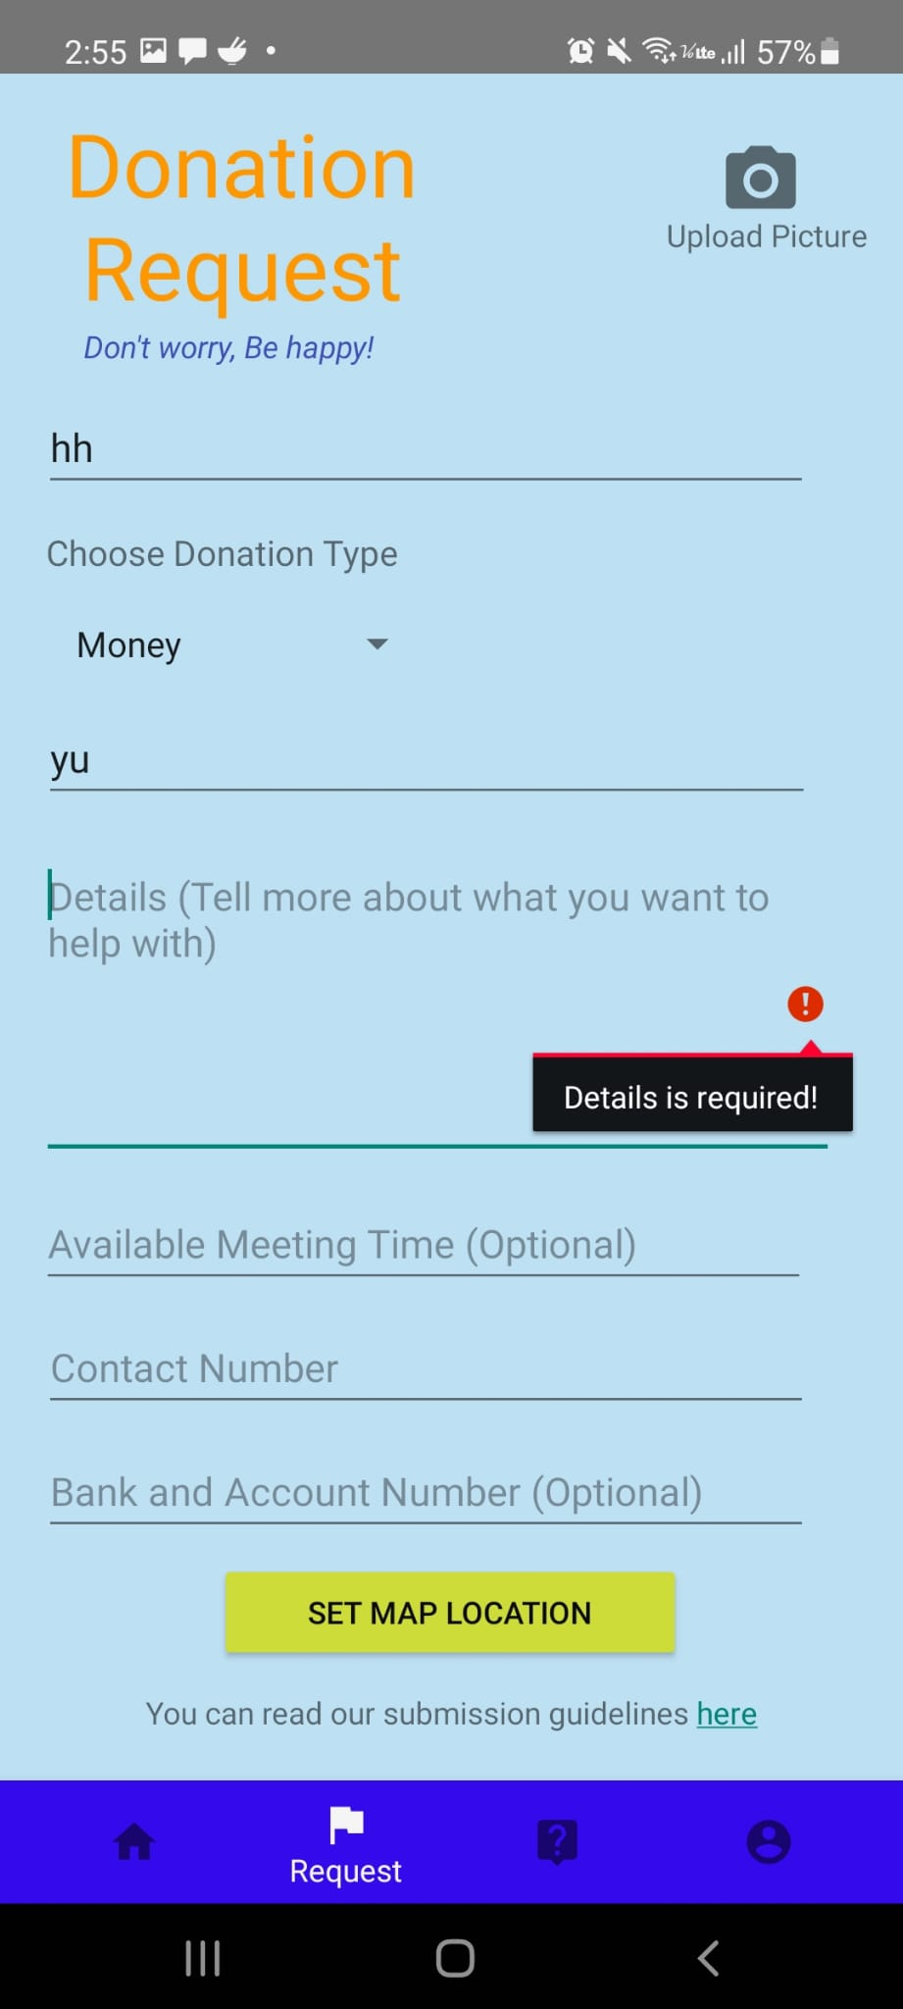

Example of error message that will pop up if the *Details* field is left empty.

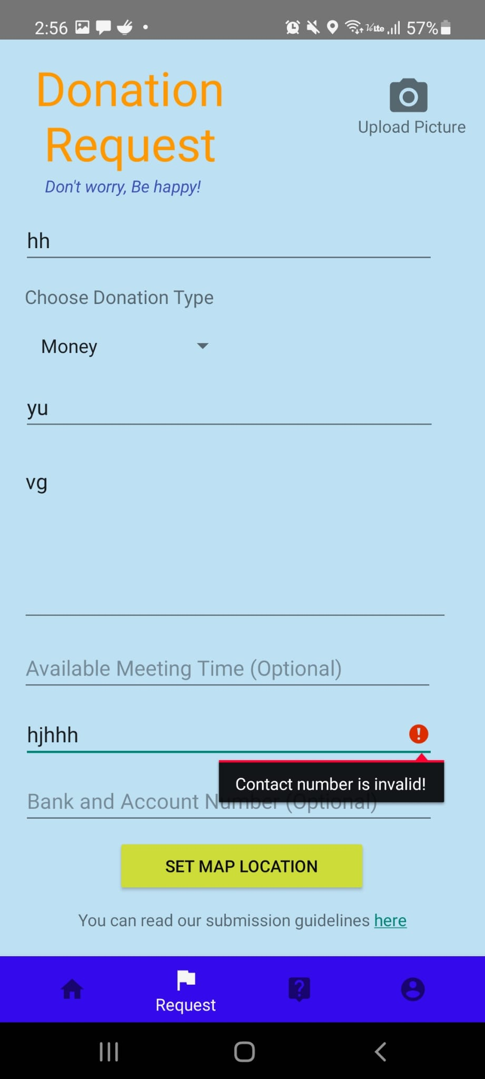

Example of error message that will pop up if the *Contact Number* field is left empty or if invalid input is entered.

// Use megat picture upload here

After correctly filling in every field, users can click the set map location button to upload their request to the map for every donor in the area to see and help.

// Use megat’s set map location here

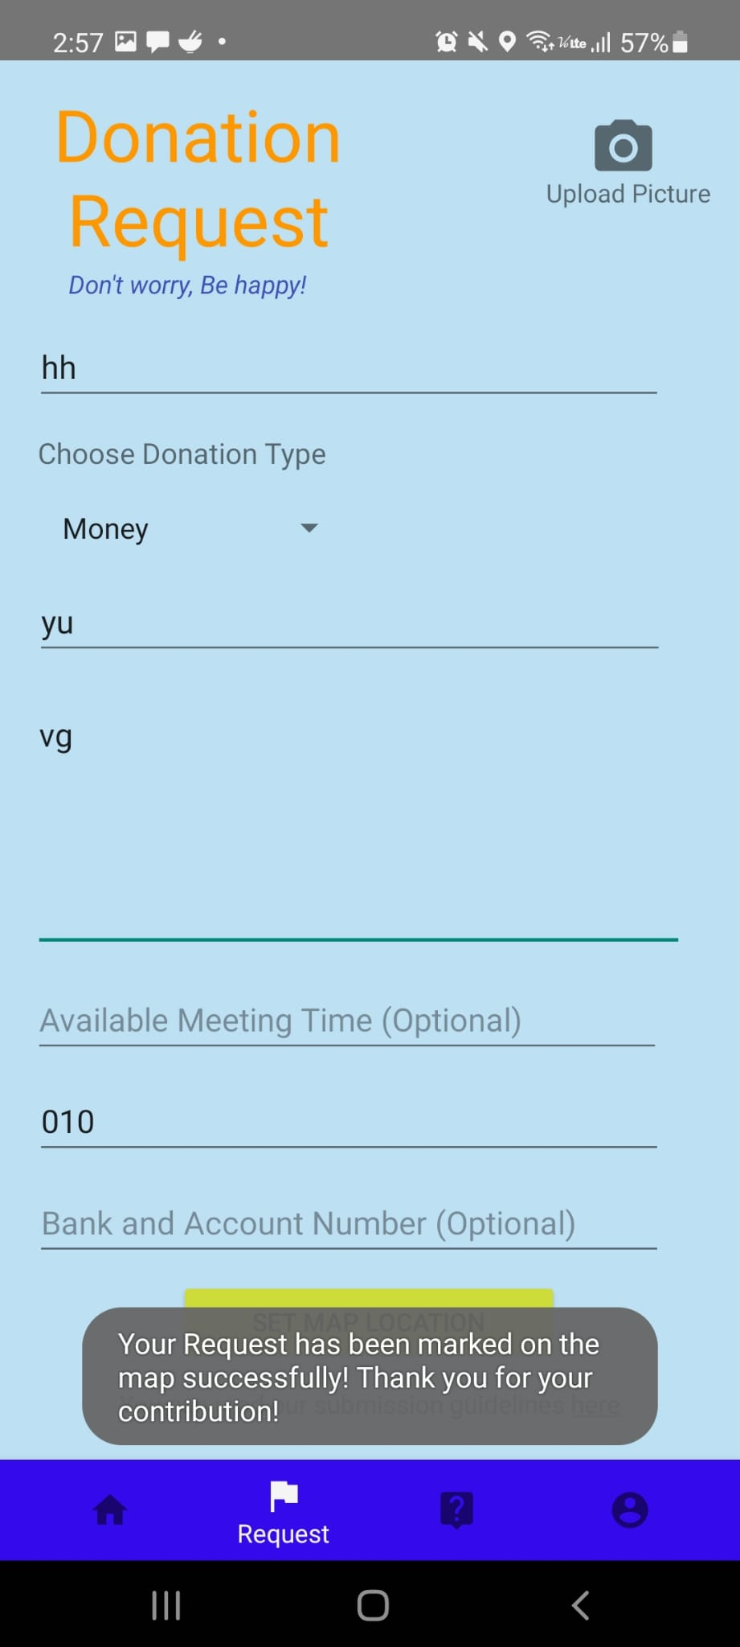

After successfully setting up their location, users will be prompted with pop up message informing that their request had been successfully marked on the map.

The flowchart below describes the process that users went through when uploading their requests.